Lab Program Number: 7 Date: 2082-04-25

Title: Creating Network Topologies using Packet Tracer

**Theory**

**Network Topology**

A network topology refers to the specific arrangement of devices in a network and the way data flows between them. It represents the physical layout or the logical interconnection of nodes. Choosing the right topology is important for efficient communication, better performance, and easier troubleshooting within a network. Understanding various topologies helps in designing networks that meet specific needs and can be easily maintained.

**Different types of Network Topologies:**

1. Bus Topology
2. Ring Topology
3. Star Topology
4. Mesh Topology
5. Tree Topology
6. Hybrid Topology

**Ring Topology**

A ring topology is a network arrangement in which each device is connected to exactly two other devices, forming a closed loop. Data travels in one or both directions around the ring, passing through each device until it reaches its destination.

**Component Used**

**Hardware:** Switches (4), Ethernet cables, End devices (4)

**Software:** Cisco Packet Tracer

**Network Diagram**

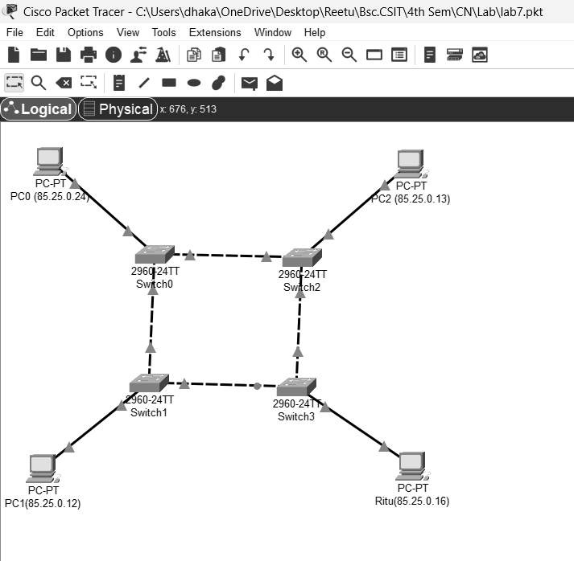

Fig: Network map for Ring Topology

**Procedure**

The procedure for creating the ring topology is shown in the image using Cisco Packet

Tracer:

**Step 1: Launch Cisco Packet Tracer**

Fig: Workspace for Network Design

**Step 2: Add the network devices to the workspace**

* 1. From the Device-Type Selection box, choose the following devices and add them to the workspace:

Four 2960-24TT switches

Four PCs (labelled PC0, PC1, PC2, Ritu)

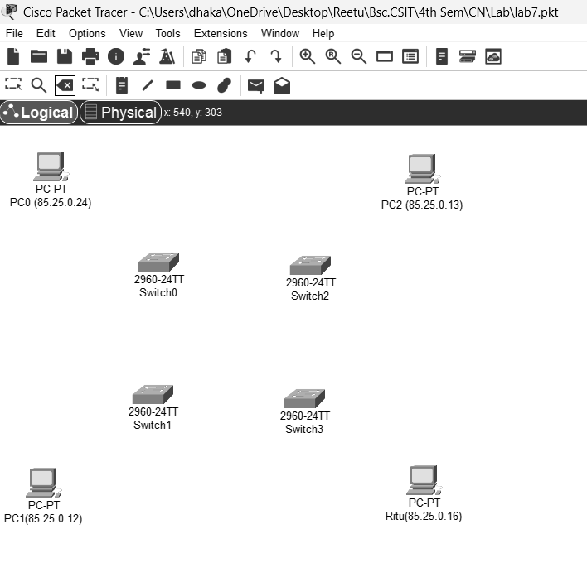

Fig: Switches and PCs for Ring Topology

**Step 3: Connect the devices**

* 1. Use the copper straight-through cable to connect each PC to one of the available ports on each switch and copper cross-over to connect between each adjacent switch.
  2. Ensure that each connection is made properly.



Fig: Connection between Switch and PCs

**Step 4: Configure IP addresses**

* 1. Right-click on each PC and Select “IP configuration”
  2. In the IP configuration window, enter the IP address as (85.25.0.12, 85.25.0.13, 85.25.0.16, 85.25.0.24), subnet mask, and default gateway for each PC.

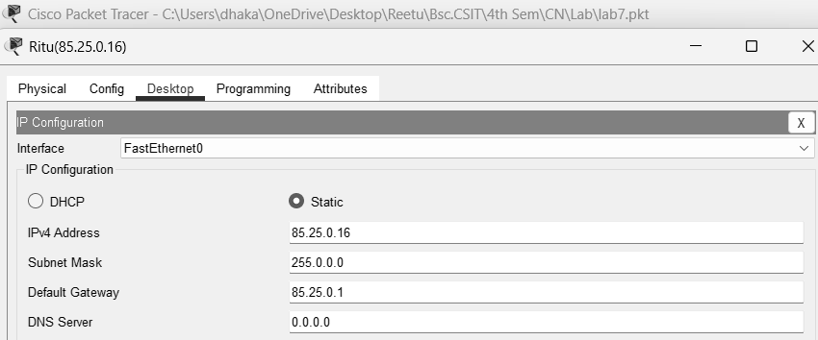

Fig: IP configuration

**Step 5: Verify Connectivity:**

* 1. To test whether the network is working, you can ping other devices on the network from each PC.
  2. To ping another device, open a command prompt on the PC and type "ping <IP address of the other device>."
  3. If the ping is successful, you should see replies from the other device.

Fig: Connectivity test between Ritu and PC0

Fig: Connectivity test between PC1 and PC2

**Star Topology**

Star topology connects all devices to a single central node, which manages and controls all data transmissions between devices.

**Component Used**

**Hardware:** Switches (1), Ethernet cables, End devices (5).  
**Software:** Cisco Packet Tracer

**Network Diagram**

Fig: Network Map for Star Topology

**Procedure**

The procedure for creating the Star topology is shown in the image using Cisco Packet

Tracer:

**Step 1: Launch Cisco Packet Tracer**

Fig: Workspace for Network Design

**Step 2: Add the network devices to the workspace**

* 1. From the Device-Type Selection box, choose the following devices and add them to the workspace:

One 2960-24TT switches

Five PCs (labelled PC0, PC1, PC2, PC3, Ritu)

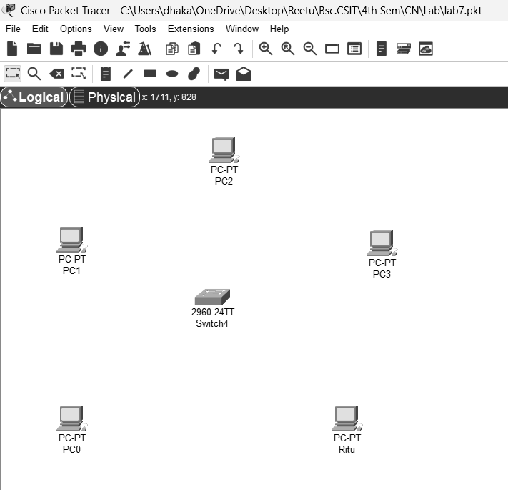

Fig: Switches and PCs for Star Topology

**Step 3: Connect the devices**

* 1. Use the copper straight-through cable to connect each PC to one of the available ports on the switch
  2. Ensure that each connection is made properly.

Fig: Connection between Switch and PCs

**Step 4: Configure IP addresses**

* 1. Right-click on each PC and Select “IP configuration”
  2. In the IP configuration window, enter the IP address as (66.55.44.11, 66.55.44.15, 66.55.44.17, 66.55.44.21, 66.55.44.30), subnet mask, and default gateway for each PC.

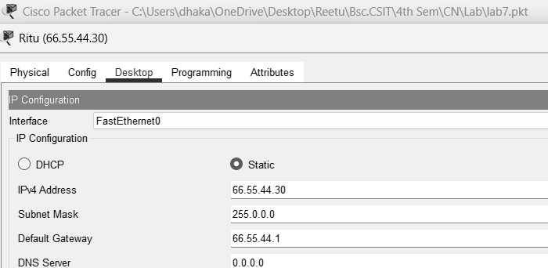

Fig: IP configuration

**Step 5: Verify Connectivity:**

To test whether the network is working, you can ping other devices on the network from each PC.

To ping another device, open a command prompt on the PC and type "ping <IP address of the other device>."

If the ping is successful, you should see replies from the other device.

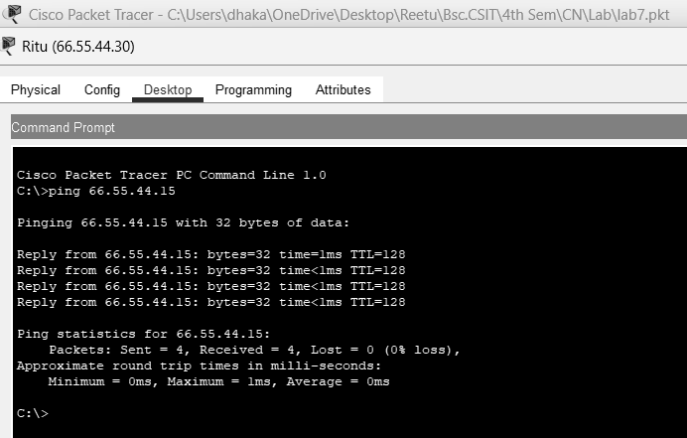

Fig: Connectivity test between Ritu and PC1

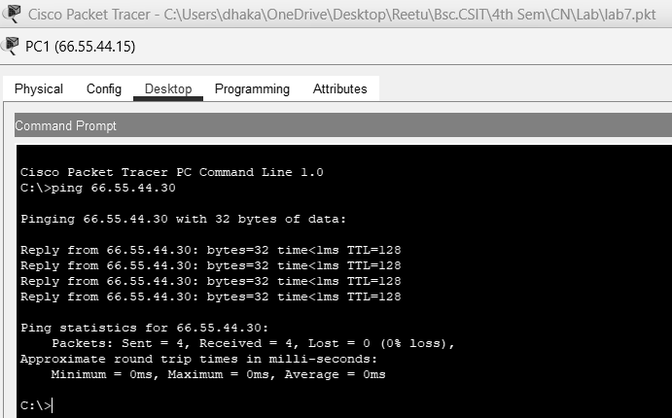

Fig: Connectivity test between PC1 and Ritu

**Mesh Topology**  
Mesh topology is a type of network setup where each device is connected directly to every other device, ensuring multiple redundant paths for data to travel, which enhances reliability and fault tolerance.

**Component Used**

**Hardware:** Switches (4), Ethernet cables, End devices (4).  
**Software:** Cisco Packet Tracer

**Network Diagram**

Fig: Network Map for Mesh Topology

**Procedure**

The procedure for creating the Mesh topology is shown in the image using Cisco Packet

Tracer:

**Step 1: Launch Cisco Packet Tracer**

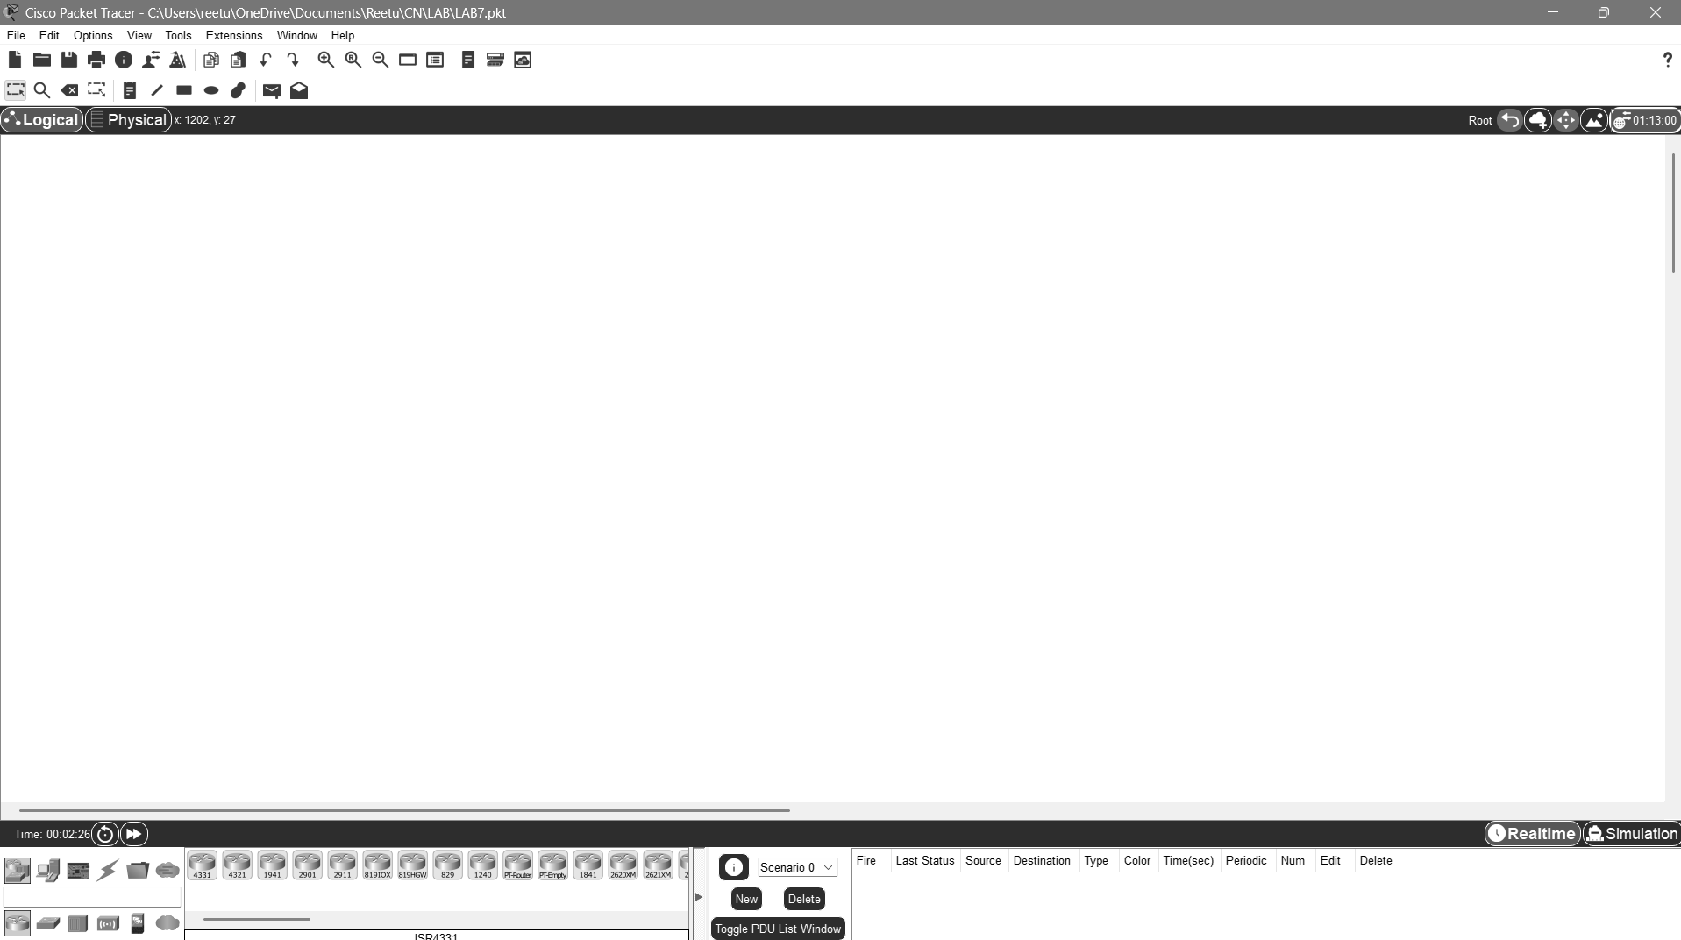

Fig: Workspace for Network Design

**Step 2: Add the network devices to the workspace**

* 1. From the Device-Type Selection box, choose the following devices and add them to the workspace:

One 2960-24TT switches

Four PCs (labelled PC0, PC1, PC2, Ritu)

Fig: Switches and PCs for Mesh Topology

**Step 3: Connect the devices**

* 1. Use the copper straight-through cable to connect each PC to one of the available ports on the switch
  2. Ensure that each connection is made properly.

Fig: Connection between Switch and PCs

**Step 4: Configure IP addresses**

* 1. Right-click on each PC and Select “IP configuration”
  2. In the IP configuration window, enter the IP address as (175.16.0.13, 175.16.0.14, 175.16.0.15, 175.16.0.16), subnet mask, and default gateway for each PC.

Fig: IP configuration

**Step 5: Verify Connectivity:**

* 1. To test whether the network is working, you can ping other devices on the network from each PC.
  2. To ping another device, open a command prompt on the PC and type "ping <IP address of the other device>."
  3. If the ping is successful, you should see replies from the other device.

Fig: Connectivity test between PC0 and PC1

Fig: Connectivity test between PC2 and Ritu

**Conclusion**

In this lab, we explored the creation and configuration of various network topologies using Cisco Packet Tracer. This practical exercise helped us understand how different devices are connected, how data flows between them, and how networks can be managed effectively. By designing and simulating topologies, we gained knowledge of placing and configuring devices such as switches, routers, and end devices. Furthermore, testing connectivity ensured that the configurations were accurate and functional. Overall, the lab enhanced our ability to analyse, implement, and troubleshoot networks in a simulated environment, preparing us for real-world networking scenarios.